**PREPARE ESP-IDF PROGRAMMING ENVIRONMENT FOR ESP32**

**Step 1: Download the environment – MSYS32**

* Go to: <https://dl.espressif.com/dl/esp32_win32_msys2_environment_and_gcc8_toolchain-20191220.zip>
* Download the latest Windows all-in-one toolchain & MSYS2 zip file (~600mb)
* UNRAR the zip file in C:/ 🡪 done setting up the pre-built environment.

**Step 2: Setting up the ESP-IDF framework**

* Open mingw32.exe and start typing:

mkdir -p ~/esp

cd ~/esp

git clone --recursive https://github.com/espressif/esp-idf.git

* [Add](https://docs.espressif.com/projects/esp-idf/en/v3.2.2/get-started/add-idf_path-to-profile.html) IDF_PATH to user profile:
  + Open the **export_idf_path.sh** in the crucial_files folder (within this folder) and fix the user to your user, then copy it to the directory: C:\msys32\etc\profile.d
  + Close MSYS2 window and reopen it and enter: printenv IDF_PATH to check the path
* Configure ESP-IDF to a useable version (old version, you can try to upgrade it later):

cd $IDF_PATH

git fetch

git checkout release/v3.2

git pull

git submodule update --init --recursive

python --version

python -m pip install --user -r $IDF_PATH/requirements.txt

**Step 6: Set up Arduino as a component in ESP-IDF**

* Go to project folder, and type in

cd workspace/components/arduino

git checkout 1.0.2

git submodule update --init --recursive

* Replace cc.h from crucial_files folder into cc.h in:

C:\msys32\home\minha\esp\esp-idf\components\lwip\lwip\test\unit\esp\arch

This cc.h has been changed from:

#include "ports/unix/port/include/arch/cc.h"

To

#include "lwip/port/esp32/include/arch/cc.h"

**Step 7: open MSYS2 (mingw32.exe) and move to project folder (workspace/)**

* Try to compile source code with

make clean

make -j4 app

* Final message should be like this:

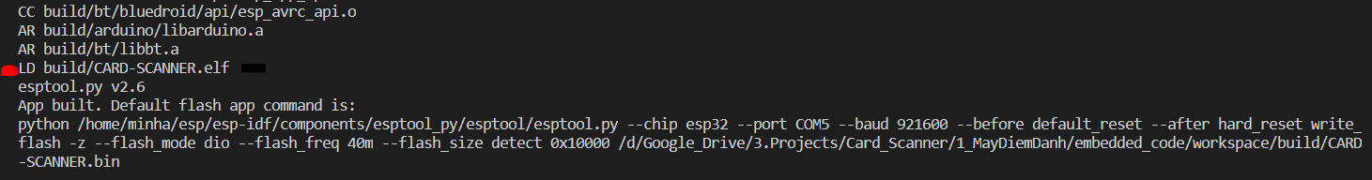

* If the above message appears, then congratulation, you are properly set up esp-idf environment for this project.
* However, this environment is out dated. If you need to upgrade to the latest release, please make backup where needed since it will need a lot of careful modification to successfully compile with newer version.

**You can now use VScode or your favorite text editor to edit the code**.